

Behaviour Policy

Edenham C of E Primary School



Policy Co-Ordinator: Headteacher
Policy Dated: March: 2023
Presented to Academy Board: October 2025
Date to be Reviewed: October 2026
Review Cycle: Annually

Let us run with perseverance the race set before us – Hebrews 12:1

The Rational

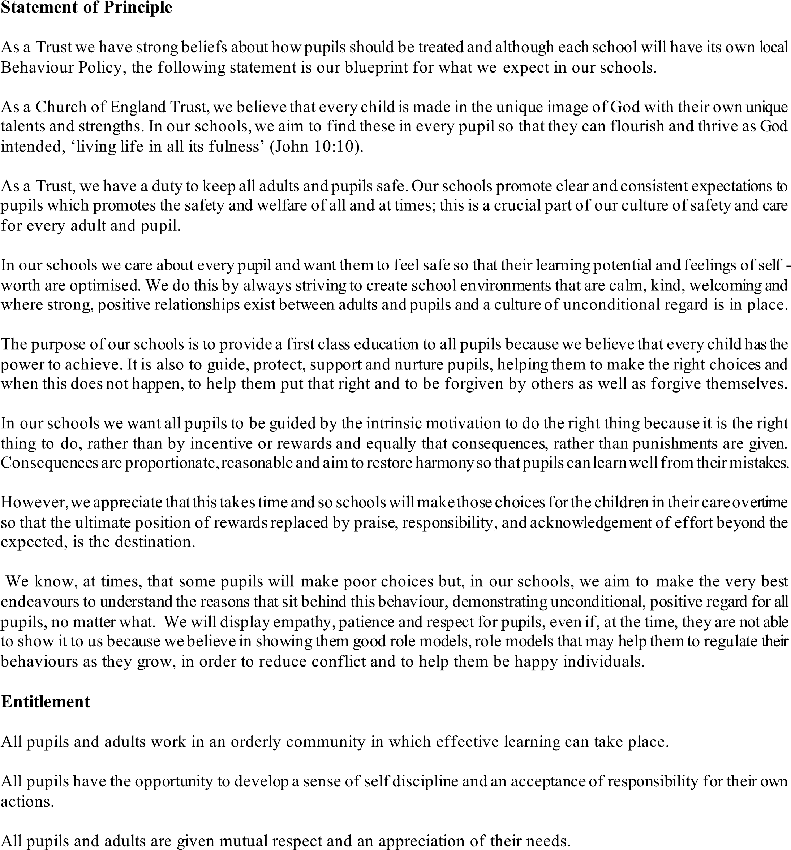
At Edenham C of E Primary School we believe that:
- It is essential that our school has a positive ethos;
- All members of the school community have the right to feel safe;
- All members of the school community have a right to be respected;
- Good behaviour is a necessary condition for teaching and learning to take place and that all members of the school community have the right to learn;
- It is essential that school and parents work in partnership to promote and encourage good standards of behaviour;

At Edenham C of E Primary School we are committed to providing a safe learning environment in which the pupils are encouraged to treat each other with respect and kindness in every aspect of their lives. The principle aim of this policy is to ensure that good behaviour assists the school to develop the potential of all pupils. Our Christian values motivates us to follow in Jesus’ example when we apply our anti-bullying and behaviour policy. At our Christian school, outstanding behaviour is rewarded and inappropriate behaviour is dealt with using a range of reflective, consistent and fair consequences ensuring children know we are here to support them. Christ’s message of forgiveness is implicit in all we do. It is always made clear to a child that it is the behaviour we find unacceptable- not them.
“Be kind to one another, tender hearted, forgiving one another, as God in Christ forgave you.”
Ephesians 4:32 ESV
Our rational is also based on our school’s core values. At the start of the new academic year, staff will remind pupils of our core values and these are discussed, shared and explored with the children throughout each term.
- Respect
- Wisdom
- Perseverance

Aims
We aim to:
- Promote Christian values including Compassion, Respect, Honesty, Trust, Forgiveness, and Perseverance within a caring, safe and nurturing environment.
- Create the right ethos and climate of behaviour;
- Develop in pupils a sense of making the right choices and an acceptance and responsibility for their own actions;
- Support pupils to develop further and learn from their mistakes;
- Ensure that pupils behave in a responsible manner, showing consideration, courtesy and respect for others at all times.
- Create the conditions within our school community in which there is mutual respect between all members and proper concern for each other, property and the environment;
- Develop a supportive atmosphere, in which pupils are able to give their best and are encouraged and stimulated to fulfil their potential.
- Be compassionate towards others and demonstrate and seek forgiveness if things don’t go well.

Management
We will ensure that decisions on the curriculum, organisation and other aspects of school life are aimed at enhancing positive behaviours in school. We believe that:
- Effective communication is vital between all stakeholders to ensure clarity of expectation.
- The Senior Leadership team should be available to support teachers when behavioural difficulties arise.
- The principle that good relationships are the pre-requisite of good behaviour is established throughout school.
- All staff in the school should accept responsibility for maintaining good behaviour in the classroom and elsewhere.

Responsibilities

Children’s responsibilities:

To show wisdom
- To work to the best of our abilities
- To take responsibility for our actions

To show respect
- To treat others with respect
- To treat the environment with respect
- To follow instructions from adults

To show perseverance

To always give our best effort

To be patient with those around us

Staff Responsibilities:

To show wisdom
- To have high expectations for all pupils
- To raise children’s self-esteem and develop their full potential

To show respect
- To create a safe and pleasant learning environment
- To treat all children fairly and with respect
- To recognise each child as a unique individual

To show perseverance
- To use rules and sanctions clearly and consistently
- To provide a challenging and relevant curriculum

Parents’ Responsibilities:

To show wisdom
- To make children aware of appropriate behaviour in different situations
- To support the school in ensuring children understanding the importance of these values

To show respect
- To support the school rules and expectations
- To foster good relationships with the school
- To support the school in the implementation of this Behaviour Policy

To show perseverance
- To encourage independence and self-discipline
- To positively engage with the school to support your child being the best that they can be

School systems for promoting positive behaviour

Language
Positive language focuses on identifying things that are going well, good choices that have been made, as well as tackling poor choices. We accept that ultimately the children are responsible for their own actions. This is reflected in our use of the language of choice. This fosters a move away from the idea that children are inherently ‘bad’ or ‘good’, they are however making good or bad choices.

Praise is used in a rich and focused way. We recognise that we need to be clear about what it is we are praising. Positive language focuses on how much pupils have improved rather than expecting perfection.

Positive Messages
Where appropriate, Teachers are encouraged share success and celebrate success with children’s parents/carers.

Rewards - Celebration Collective Worship
Once a week we hold Collective Worship with a theme of Celebration. There are several types of rewards that are shared here:
- Star of the week certificates (recognising success in the classroom)
- Special award certificates (recognising a child’s effort or the showing of a school value
- Additional certificates (for example for sporting or musical achievements) may also be awarded, including those received outside of school.
- Headteacher’s award may also be given

Rewards

As well as the awards presented in Celebration Collective Worships children may also receive –

Dojo Points

Stickers

A place on the proud cloud

The opportunity to re-call success or displays of good behavior to the headteacher

Sanctions

We believe in a restorative approach, whereby an incident is discussed with a child and they are educated on why it is deemed unacceptable and systems put into place to ensure that the behaviour does not occur again, however there are also the needs for sanctions. This list below is not exhaustive and each situation is dealt with individually with teachers and the headteacher using their own professional experiences to ensure equity.

Behaviour level | Behaviours displayed (not exhaustive) | Sanctions
Level 1 | Talking over an adult  Disrupting others  Not listening  Poor manners  Rudeness | A warning will be given (if necessary an explanation of why the behaviour is not appropriate)
Level 2 | Continuation of Level 1  Refusing to follow reasonable instructions  - Lack of effort with learning | Time spent in a different space to allow for reflection
Level 3 | - Use of inappropriate language  - Fighting  - Physical, verbal abuse to peers or adults  - Continuation of previous behaviour | Reflection time with a member of SLT and parents to be notified. | Incidents at this level will be recorded on CPOMS
Level 4 | Bullying of any kind  - Endangering other pupils or adults  - Damage to school property  - Persistent disruption of others learning  - Showing discrimination to others within our community | Reflection time with Head Teacher and withdrawal of privileges/rewards | Incidents at this level will be recorded on CPOMS
Internal Exclusion | A serious single event or persistently disrupting the learning of the others  *behaviors at previous levels could trigger an internal exclusion if deemed appropriate
Fixed Term Suspension  (Which could lead to permanent exclusion) | Persistent inappropriate behaviour (as mentioned above) or behaviour which puts the physical or mental wellbeing of children or adults at risk.
Permanent Exclusion | A serious risk to children and adults within school is posed or persistent breaches of the school’s behaviour policy.

In extreme circumstance physical intervention and restraint may have to be used to keep all children and adults safe. If this is needed it will be carried out by a member of staff who has received Team Teach Training and following relevant guidelines. DfE advice - Use of reasonable force

Exclusions may be for a build-up of unmanageable and unacceptable behaviour, but may also be for a one-off incident.

See also Government guidelines:
School discipline and exclusions: Exclusions - GOV.UK (www.gov.uk)

Use of Reasonable Force
In extreme circumstances where a child is at risk of causing themselves or others significant harm or compromising a safe environment, it may be appropriate to use physical intervention. Staff members have received Team Teach training. Please see the school’s Positive Handling Policy (The use of physical intervention). See also Government guidelines: Use of reasonable force in schools - GOV.UK (www.gov.uk)

Restorative Practice
Restorative Practice is not a sanction but may result in an immediate sanction (see table above) dependent on the severity of the unwanted behaviour. In some circumstances the RP process and repairing the harm may be a satisfactory outcome and no sanction may be necessary. Additionally, following a discussion, boundaries and expectations of behaviour may be established with associated consequences for non-compliance. There are four key elements to Restorative Practice (RP).

Restorative Questions
These are asked to sets of children, the wrong doer and the harmed. Discussions should always focus on the act not the actor, the deed not the doer.

Questions for wrong doer | Questions for injured party
What happened?  What were you thinking at the time? What have your thoughts been since? Who has been affected by what you did?  In what way have they been affected?  What do you think you need to do to make things right? | What did you think when you realised what had happened?  What have your thoughts been since? How has this affected you and others? What has been the hardest thing for you? What do you think needs to happen to make things right?

Monitoring of Behaviour
Behaviour is monitored by the Head Teacher using the CPOMS tracking tool and regular conversations with staff. Patterns in behaviour may be identified and addressed with children and/or parents in order to best support the children.

Additional Support
Additional support is available through the schools SEN systems and via additional interventions. We recognise that some pupils may need more support than others to develop their skills and staff are encouraged to act on concerns about a pupil’s learning, conduct or emotional behaviour as early as possible.

If necessary, pupils will be provided with an Individual Behaviour Plan. These focus around our school values and created with parents and the child.

For pupils with more significant difficulties with behaviour, the school will seek to work in partnership with outside agencies such as the Behaviour Outreach Support Service (BOSS) and the Educational Psychologist. This will usually take place after IBPs have been implemented. The school may also consider the involvement of Social Care and Health Services.

The Edenham C of E Primary School will make reasonable adjustments to the rewards, sanctions and teaching strategies within this policy in order not to disadvantage a pupil. This would apply to pupils with SEND and other pupils as their personal circumstances warranted it. Adjustments made and agreed would be shared with staff members in school. This may mean that there is an appearance of the policy not being adhered to at times as rewards and sanctions are applied ‘differently’ but pupils, staff and parents should be reassured that adjustments are only made when necessary in order to meet a pupil’s individual need.

Supporting Supply and Cover Teachers
Supply and cover teachers should be supported by:
- All staff
- Lesson planning in an easy to follow format.
- Lessons that are reasonable for someone other than the class teacher to implement and manage.
- SEND support before the supply teacher begins with a class.
- Deploying support staff to help children settle at the start of sessions where appropriate.
- Class teachers following up behavioural problems with parents when appropriate.
- Summary of the school behaviour policy.

Staff Development
The School may use external professionals to provide whole school training as required. Staffs are also signposted to relevant support and training as appropriate. In house training is provided in order to support staff development further.

Anti – Bullying

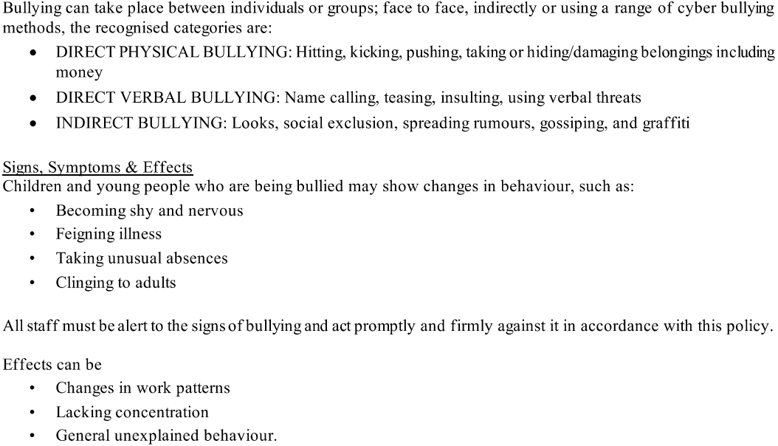
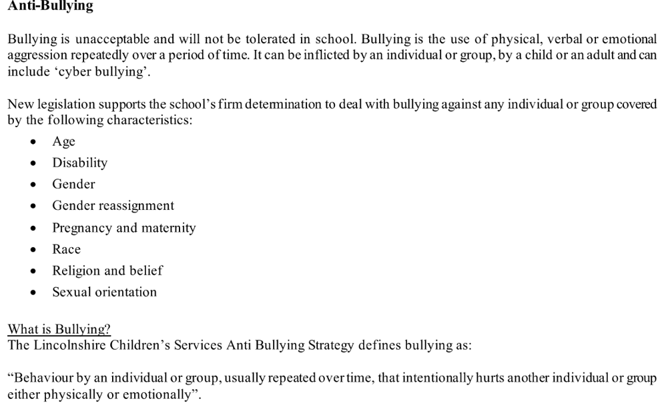

Reporting

All children are taught to report bullying, whether they themselves believe they are a victim of bullying or they have witnessed bullying.
- Children can report any incidents of bullying to staff members
- Families can contact their child’s class teacher by using the various communication links open with a report of the incident(s)
- All staff and visitors should report any incident to a member of SLT

Responding

The following steps may be taken when responding to a report of bullying?
- A clear account of the incident(s) must be recorded
- Class teachers will be kept informed
- Parents will be kept informed
- Measures appropriate to the context of the incident(s) will be used in line with the school’s behaviour policy


