Dear Children, Parents and Carers,
I hope that you have all enjoyed the break
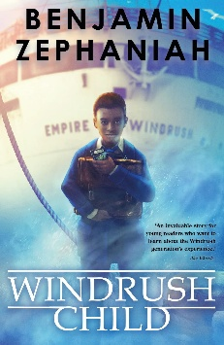
We will continue this term by exploring the text: Windrush Child by Benjamin Zephaniah The children are now delving deeper into understanding Leonard, and what it feels like to leave behind everything familiar and start again in a country that doesn’t always feel welcoming.
The book explores themes of belonging, identity, and family, as well as the resilience shown by Caribbean communities who helped rebuild post‑war Britain. So far, reading this story has generated many mature discussions and high levels of understanding and tolerance from the children about the the realities of racism, cultural displacement, and the importance of community support.
We will begin this term by writing our own persuasive pitches to the Athenian Council, to persuade them to invest in our own Ancient Greece inspired inventions! We will also write our own narrative poetry based on Ancient Greek Legends.
The children will also continue working hard to develop their handwriting and spelling skills through focused sessions throughout the week.
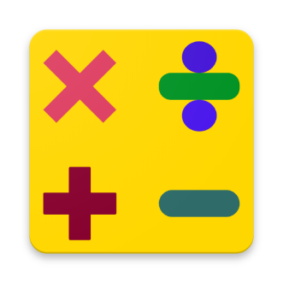
In Maths this term, we will begin by exploring percentages and the links between decimals and fractions. We will recap mental multiplication and division, statistics and geometry - properties of shape and position and direction. As always, throughout their learning in maths this term, the children will be exposed to a variety of different problem solving tasks and reasoning style questions, prompting them to draw from their knowledge and use their skills to answer them with increasing efficiency and accuracy. Our regular recapping of core arithmetic knowledge will enable them to feel more confident with this also.

This term in Science, we will be learning about light, during which we will work hard find out how our eyes work. We will research our key scientist for the term, Ibn Al-Haytham, a mathematician and physician who developed many theories linked to how light travels. We will learn all about how light moves in different circumstances, how objects are seen and how shadows are formed and how they change.
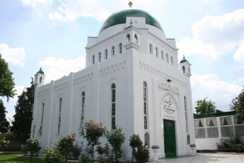
In RE this term we will be exploring the question: Do people always put their beliefs into action? This term, moving to a focus on Islamic worldviews. We will explore movement, migration and seeking refuge, as well as teachings about the Ummah and justice, linking this to both historical and contemporary case studies.
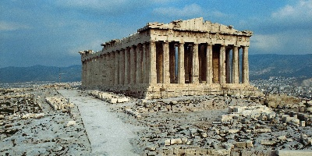
During History this term, we will be learning about the Ancient Greeks, and what impact they had on how societies function today. We will learn about the structure of Ancient Greek society, inventions, customs and achievements before investigating how these things influence our world today.
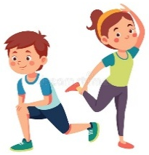
In PE this term, we will be exploring Tag Rugby. We will learn about the basic structure of the game including its rules and tactics – linking this to what we have learnt about agility and fitness in previous terms.
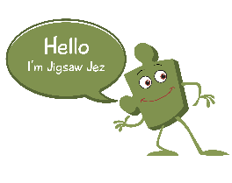
Our Jigsaw (PSHE) topic this term is ‘Healthy Me’, where we will learn about the impacts of smoking and alcohol, emergency aid, body image and positive relationships with food.

In DT this term, the children will learn about the history of the flags of Greece and others to investigate symbolism. We will practice a variety of different sewing stitches to make flags that include symbols that are important to us.
Homework
The children have a Homework Menu that includes tasks that will support them with their learning that can be completed throughout the term. They will continue to have additional homework set on Reading Eggs and Mathletics on a rotational basis each week. These will be set on a Friday starting with Mathletics, and should be completed by the following Thursday. The deadline might read differently occasionally (e.g. later than the usual week) – this is so that the task can remain open the following week to support children in school if needed.
As we know, the time that children spend reading has a huge impact on their education. It would be amazing if children can explore books on a daily basis, when they get home from school, before they go to bed or at another time that suits you family best. This does not have to be the same narrative text everyday; shorter stories and non-fiction texts provide excellent practise and a source of knowledge too. At this age, your children will be reading to themselves more often, but do check in and ask them questions about what they have read or found out as much as you can. If the children get their reading diary signed 3 times per week by an adult, they will receive a stamp towards their reading rewards.
Regular practise of times tables will also have a huge impact on the progress that we make in maths this year – very quick but very often being the most effective approach at keeping tricky facts within their working memory. The children will be becoming more and more confident with their times tables by now, so focusing on the corresponding division facts will provide them with that extra challenge. The app, ‘White Rose 1-Minute Maths’ is really simple to use and provides quick practise of a wide range of maths skills.
PE and Outdoor Education
PE lessons will be on a MONDAY this term, where the children will need to come to school in their school PE kits.
Swimming will be on a THURSDAY, where the children need to come to school dressed in their PE kits with their swimming costume underneath. Swimming replaces outdoor education this term.
Thank you for your continuing support,
Mr Liddle

