Dear Children, Parents and Carers,
I hope that you have all enjoyed the Christmas break – welcome to 2026 in Blackman Class!
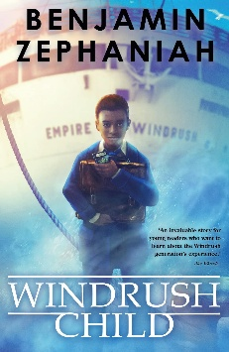
We will begin the spring term by exploring the text: Windrush Child by Benjamin Zephaniah The story follow the journey of Leonard, a young boy who travels from Jamaica to England as part of the Windrush generation. Through Leonard’s eyes, children see what it feels like to leave behind everything familiar and start again in a country that doesn’t always feel welcoming.
The book explores themes of belonging, identity, and family, as well as the resilience shown by Caribbean communities who helped rebuild post‑war Britain. It also gently introduces children to the realities of racism, cultural displacement, and the importance of community support.
We will begin this term by writing our own narratives based on a challenging journey similar to Leonard’s. We will continue our work on exploring emotive and figurative language, to write in a complex and thought-provoking manner.
The children will also continue working hard to develop their handwriting and spelling skills through focused sessions throughout the week.
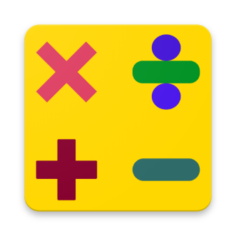
In Maths this term, we will begin by revisiting and exploring multiplication and division to include multiples, factors, prime and composite numbers.. We will focus on fractions this term by comparing and ordering fractions as well as adding and subtracting them. We will end the term by revisiting formal multiplication and subtraction strategies. As always, throughout their learning in maths this term, the children will be exposed to a variety of different problem solving tasks and reasoning style questions, prompting them to draw from their knowledge and use their skills to answer them with increasing efficiency and accuracy. Our regular recapping of core arithmetic knowledge will enable them to feel more confident with this also.
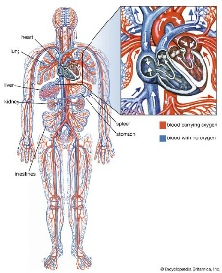
This term in Science, we will be learning about animals including humans, during which we will work hard find out how our choices affect how our bodies work. We will research our key scientist for the term, Sir Richard Doll, who proved the link between lung cancer and smoking. We will learn all about our hearts and how blood moves around the body. We will also explore the impact that a healthy and unhealthy diet can have on our bodies along with the impact of exercise, and helpful and harmful drugs.
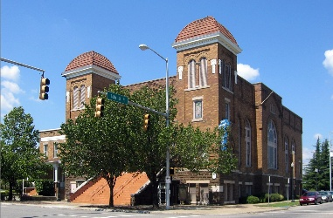
In RE this term we will be exploring the question: Do people always put their beliefs into action? Using various case studies throughout history, pupils will ask philosophical questions about how beliefs can inspire action - both positively and negatively.


During Geography this term, we will be learning about North America, and what makes it an attractive tourist destination. We will learn about key locations in the continent, what there is to do and explore in terms of both human and physical geography, as well as exploring how tourism could be more sustainable.
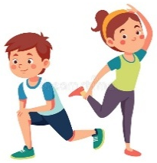
In PE this term, we will be exploring Tag Rugby. We will learn about the basic structure of the game including its rules and tactics – linking this to what we have learnt about agility and fitness in previous terms.
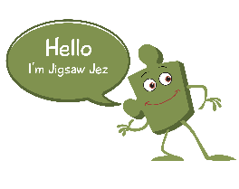
Our Jigsaw (PSHE) topic this term is ‘Dreams and Goals’, where we will learn about realistic dream lifestyles, jobs and careers, dreams and goals of young people from different cultures and how we support others to achieve their goals.

In Art this term, the children will learn about the North American artist, Alma Thomas and her unique style when creating landscape paintings. The children will learn how to use pastels to replicate this style using a variety of different techniques.

Homework
The children have a Homework Menu that includes tasks that will support them with their learning that can be completed throughout the term. They will continue to have additional homework set on Reading Eggs and Mathletics on a rotational basis each week. These will be set on a Friday commencing on Friday 9th January, starting with Mathletics, and should be completed by the following Thursday. The deadline might read differently occasionally (e.g. later than the usual week) – this is so that the task can remain open the following week to support children in school if needed.
As we know, the time that children spend reading has a huge impact on their education. It would be amazing if children can explore books on a daily basis, when they get home from school, before they go to bed or at another time that suits you family best. This does not have to be the same narrative text everyday; shorter stories and non-fiction texts provide excellent practise and a source of knowledge too. At this age, your children will be reading to themselves more often, but do check in and ask them questions about what they have read or found out as much as you can. If the children get their reading diary signed 3 times per week by an adult, they will receive a stamp towards their reading rewards.
Regular practise of times tables will also have a huge impact on the progress that we make in maths this year – very quick but very often being the most effective approach at keeping tricky facts within their working memory. The children will be becoming more and more confident with their times tables by now, so focusing on the corresponding division facts will provide them with that extra challenge. The app, ‘White Rose 1-Minute Maths’ is really simple to use and provides quick practise of a wide range of maths skills.

PE and Outdoor Education
PE lessons will be on a MONDAY this term, where the children will need to come to school in their school PE kits.
Outdoor Education will be on a FRIDAY, where the children need to come to school dressed appropriately, with waterproof clothing and wellies, just in case!
Thank you for your continuing support,
Mr Liddle

