Dear Children, Parents and Carers,
Following our first half term of this school year, I hope that you all had a lovely half term break. We have another interesting term ahead of us, with lots to be learned and enjoyed!
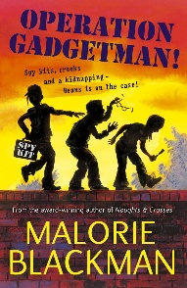
We will continue with our class text, ‘Operation GadgetMan!’ by Malorie Blackman. This s a thrilling and humorous adventure for readers aged 8–11. The story follows Beans, a clever and determined girl whose dad—nicknamed Gadgetman—is an eccentric inventor of bizarre and brilliant gadgets, from exploding biscuits to spy kits. When Gadgetman is suddenly kidnapped, Beans and her friends must use their wits and the gadgets he left behind to track him down. Along the way, they uncover a dangerous criminal plot and learn the value of courage, friendship, and resourcefulness.
We will begin this term by writing our own remembrance poems, using In Flanders Fields as a stimulus. We will explore emotive and figurative language such as personification, as well as poetic structure to write complex and thought-provoking poems. Following this, we will use our class text as a stimulus for a piece of narrative writing, where we will explore paragraphing, descriptive language, subordinate clauses, and varying sentence length.
The children will also continue working hard to develop their handwriting and spelling skills through focused sessions throughout the week.
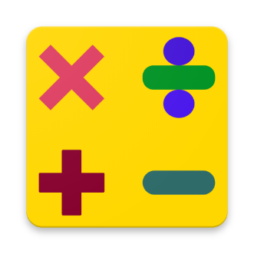
In Maths this term, we will begin by revisiting and exploring formal written methods for multiplication. We will continue to explore rounding decimals, short division (using fractions and decimals to represent remainders in year 6), properties of shape and angles. As always, throughout their learning in maths this term, the children will be exposed to a variety of different problem solving tasks and reasoning style questions, prompting them to draw from their knowledge and use their skills to answer them with increasing efficiency and accuracy. Our regular recapping of core arithmetic knowledge will enable them to feel more confident with this also.
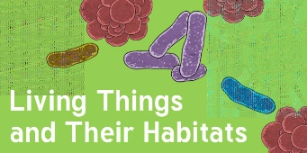
This term in Science, we will be learning about living things and their habitats, during which we will work hard find out how we can classify living things into groups. We will research our key scientist for the term, Carl Linnaeus and his taxonomy for the classification of living organisms. We will learn what microorganisms are, the differences between vertebrates and invertebrates and different classification approaches and how they work.
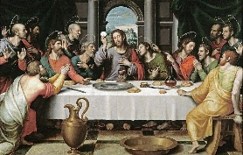
In RE this term we will be exploring the question: Should creativity matter in religious worldviews? – with a focus on art – continuing on from our focus on music last term. In this unit, pupils build on learning from KS1 by engaging in interpretation of religious narratives about the origins of the universe. They will apply this learning to the diverse ways in which religious people express - or do not express - their creativity through art.

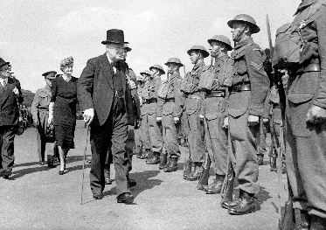
During our first History topic, we will be learning about World War II, in order to form opinions on the question: How did World War II affect people’s lives? During our History lessons, the children will learn key dates and events leading up to the war as well as during it, key individuals of this time period, and how Britain was impacted during the war through the evacuation of children, rationing and the role of women.
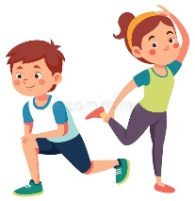
In PE this term, we will be exploring gymnastis. We will learn about how strength, agility and balance, co-ordination and determination can help us to complete various different gymnastic sequences,

Our Jigsaw (PSHE) topic this term is ‘Celebrating Difference’, where we will learn about different cultures, racism, types of bullying, the influence of money and celebrating difference across the world.
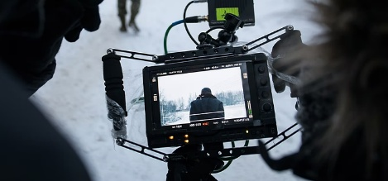
In Computing, we will learn about creating media, specifically video production. This unit gives learners the opportunity to learn how to create short videos in groups. As they progress through this unit, they will be exposed to topic-based language and develop the skills of capturing, editing, and manipulating video.
Homework
The children have a Homework Menu that includes tasks that will support them with their learning that can be completed throughout the term. They will continue to have additional homework set on Reading Eggs and Mathletics on a rotational basis each week. These will be set on a Friday commencing on Friday 14th November, starting with Mathletics, and should be completed by the following Thursday.
As we know, the time that children spend reading has a huge impact on their education. It would be amazing if children can explore books on a daily basis, when they get home from school, before they go to bed or at another time that suits you family best. This does not have to be the same narrative text everyday; shorter stories and non-fiction texts provide excellent practise and a source of knowledge too. At this age, your children will be reading to themselves more often, but do check in and ask them questions about what they have read or found out as much as you can. If the children get their reading diary signed 3 times per week by an adult, they will receive a stamp towards their reading rewards.
Regular practise of times tables will also have a huge impact on the progress that we make in maths this year – very quick but very often being the most effective approach at keeping tricky facts within their working memory. The children will be becoming more and more confident with their times tables by now, so focusing on the corresponding division facts will provide them with that extra challenge. The app, ‘White Rose 1-Minute Maths’ is really simple to use and provides quick practise of a wide range of maths skills.

PE and Outdoor Education
PE lessons will be on a MONDAY this term, where the children will need to come to school in their school PE kits.
Outdoor Education will be on a FRIDAY, where the children need to come to school dressed appropriately, with waterproof clothing and wellies, just in case!
Thank you for your continuing support,
Mr Liddle

