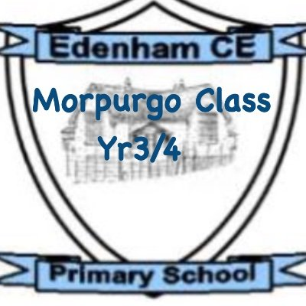
Dear Children, Parents, and Carers,
I hope you all had a restful and fun-filled week. We have got another busy term ahead of us. It has been lovely to see the children settling back into school and enjoying their learning. If you have any questions, don’t forget to use your communication books.
Thanks as always for your support,
Miss Burrows

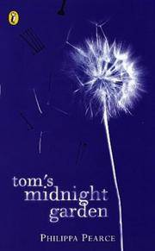
Our class read for this term is Tom’s Midnight Garden. Children will be working on their fluency through applying different skills. These skills are expression, automaticity, rhythm and phrasing and smoothness. The book will be used during our whole class-reading sessions. Our text explores the themes of loneliness, friendship and empathy. The children have really been enjoying discussing new vocabulary and comparing how things have changed from the past to the present.
Our first writing piece this term, will be an explanation text which will be based upon the Water Cycle. We will be using applying our recent learning about different text structures to independently structure these piece of writing and will be using a variety of sentence structures and punctuation within this piece of writing. We will then be moving on to exploring stories from different cultures with the end goal of writing a narrative making links within our writing to help with the flow of it.
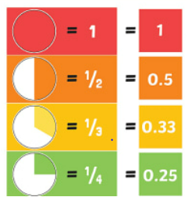
Within Maths this term, we will be moving on to geometry and properties of shape. Children will be identifying different types of angles and turns. There will also be some work on classification of shapes. We will then be revisiting multiplication, but working on formal methods of writing out 2 x 1 digit sums (25 x 4) and 3 x 1 digit sums (389 x 5).


The Science topic this term, is forces and magnets. Within this topic, we will be recognising what push and pull are and identifying that they are a force. We will be investigating how things move on different surfaces. We will use this piece of learning to draw graphs and write conclusions. We will also be finding out more about who William Gilbert is and what he discovered.

In RE, the children will again be using their understanding of the concept of duty to the ways in which religious people try to live a good life. Drawing on questions and methods from the Human/Social Sciences, Theology and Philosophy, the children will explore the life of St Francis of Assisi.
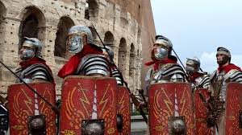
Within History, we will be learning about the Ancient Romans and how Roman society was structured. We will be exploring how the Roman Army was successful in invading other countries and looking at how the Roman Empire expanded.
In Art / DT we will continue to work on using acrylic colours to create a desired tone and will be focusing on ensuring they are using accurate brush strokes.
In French, our next topic will be Les glaces (ice cream). The children will learn 10 flavours of ice-cream and the transactional language required to purchase an ice-cream in French. By the end of the unit, the children will have the knowledge and skills to take part in a role-play activity where they will order a cone or cup of ice-cream in the flavour(s) of their choice, specifying how many scoops of each they would like.
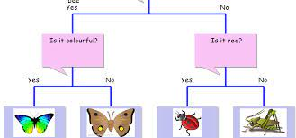
Our next computing topic will be based around data and information. The children will be developing their understanding of what a branching database is and how to create one. They will use yes/no questions to gain an understanding of what attributes are and how to use them to sort groups of objects. We will be creating physical and on-screen branching databases and will be considering where these are used in real life.

In PSHE, our fourth unit is based around ‘Healthy Me’. We will begin by understanding how exercise affects my body and why my heart and lungs are such important organs. We will be identifying things, people and places that we need to keep safe from and identifying some strategies for keeping ourselves safe.
Homework
The most valuable homework you can do with your child is to set aside a short and daily piece of time where you share, read and enjoy books together. We have set the children a challenge of reading every day in March and recording their reading on their bookmark. We will be collecting these in on the last day of March for a chance to be entered into the prize draw.
I will continue to set work on Mathletics throughout the term – if your child is unsure about their login details, please pop a note in their communication book
We continue to work on our recall of times tables, building speed and accuracy. In school we use https://www.mrsthompson.co.uk/ to help children build their confidence at answering questions within a 6 second time limit. It would be great if children could do this at home as well, they can track their score using the grids we will be sticking in reading records to see how much they improve! As ever, if you have any questions, please feel free to ask.
PE
PE lessons will be on a Monday, please can you ensure your child comes into school in their PE clothing. Children will be focusing on different invasion games this term.
Outdoor Education
The children will have one session of Outdoor Education each week on a Friday. Please can the children come to school dressed appropriately and ensure they bring in a waterproof coat and a pair of named wellies.

