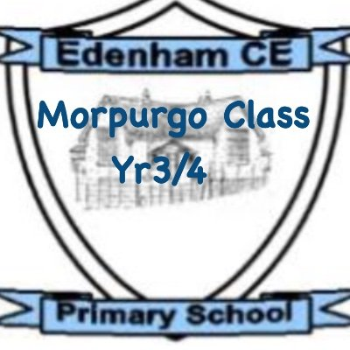
Dear Children, Parents, and Carers,
I hope you have all had a Happy Christmas and I wish you all a Happy New Year. Don’t forget if you ever have any questions, messages or queries, please use the communication book. I look forward to hearing about what the children got up to over the Christmas break.
Thanks as always, Miss Burrows
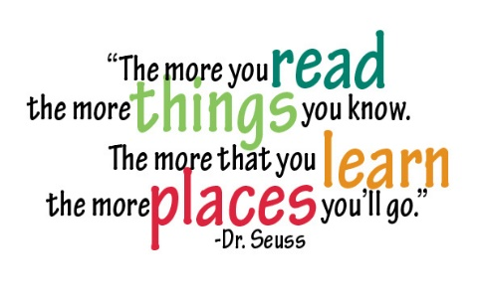
Our class read for this term is Tom’s Midnight Garden. Children will be working on their fluency through applying different skills. These skills are expression, automaticity, rhythm and phrasing and smoothness. The book will be used during our whole class-reading sessions. Our text explores the themes of loneliness, friendship and empathy.
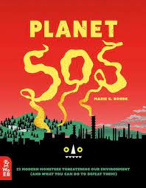
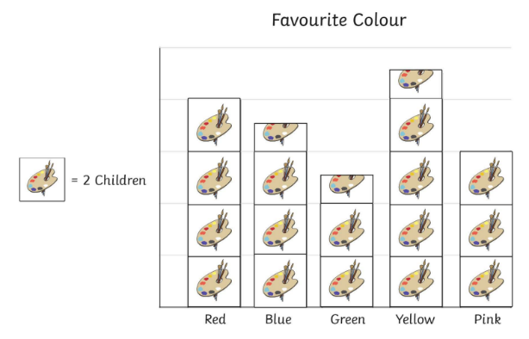
Our first writing piece this term, will be a non-chronological report which will be based upon environmental issues explored in Planet SOS. We will be using paragraphs that are organised by key ideas and using links between our sentences to help navigate the reader from one idea to the next. We will be using a variety of sentence structures and adverbs as well as fronted adverbials. We will then be moving on to writing a persuasive text linked into our class read.
This term in Maths, we will begin with statistics. Within this unit, children will be learning how to interpret and represent data. They will be exposed to bar graphs, pictograms, tally charts and tables. Then we will be moving onto properties of shapes. Children will be identifying horizontal and vertical lines, and pairs of perpendicular lines and parallel lines. Our learning will also focus on lines of symmetry found in 2D shapes.
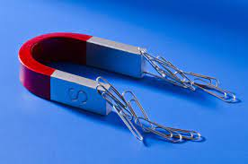
The Science topic this term, is forces and magnets. Within this topic, we will be recognising what push and pull are and identifying that they are a force. We will be investigating how things move on different surfaces. We will use this piece of learning to draw graphs and write conclusions. We will also be finding out more about who William Gilbert is and what he discovered.
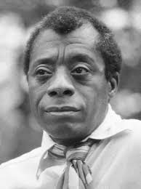
In RE, the children will be applying their understanding of the concept of duty to the ways in which non-religious people try to live a good life. The children will be exploring the life of James Baldwin and the golden rules he applied to his life.
In Geography, we will be learning about the Mediterranean. We will begin with locating the Mediterranean on a map and then will be describing the key human features of the Mediterranean. We will then be using this knowledge to compare and contrast the Mediterranean and the United Kingdom to understand why people visit the Mediterranean.
In Art, we will be focusing on using acrylic paints. Our important artists this term will be Henri Matisse and Oliver Jeffers. Children will be using different colours to create a desired tone and will be focusing on ensuring they are using accurate brush strokes.
In French, our third topic will be Les Legumes (vegetables). The children will learn 10 common vegetables in their plural form with their definite articles. They will learn the basic transactional language required to take part in a role-play activity based on buying different quantities of vegetables from a market stall.
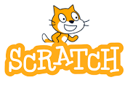
Our next computing topic will be exploring the concept of sequencing in programming through Scratch. It begins with an introduction to Scratch. The children will be introduced to a selection of motion, sound, and event blocks which they will use to create their own programs, featuring sequences.
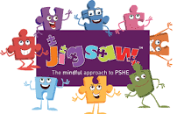
In PSHE, our third unit is based around ‘Dreams and Goals. We will begin by respecting and admiring people who overcome obstacles and achieve their dreams and goals (e.g. through disability). The children will then identify a dream/ambition that is important to them. We will be breaking down a goal into a number of steps and know how others could help me to achieve it. We will be learning who is responsible for their learning.
In PE, our third unit of work is based all around ‘Football’. The children will develop their understanding of the attacking and defending principles of invasion games. The children will have to think about how they use skills, strategies and tactics to outwit the opposition. They will learn that in football, you do this by maintaining possession and moving the ball towards the goal to score.
Homework
The most valuable homework you can do with your child is to set aside a short and daily piece of time where you share, read and enjoy books together.
If you think your child would benefit from having some additional work sent home to support their understanding of work covered in Maths, please do feel free to write a message in the communication book.
PE
PE lessons will be on a Monday, please can you ensure your child comes into school in their PE clothing.
Swimming
As you will be aware, Morpurgo class will be attending swimming lessons on a Thursday morning. Please ensure your child comes into school with their swimming costume or swimming shorts underneath their PE kit.

