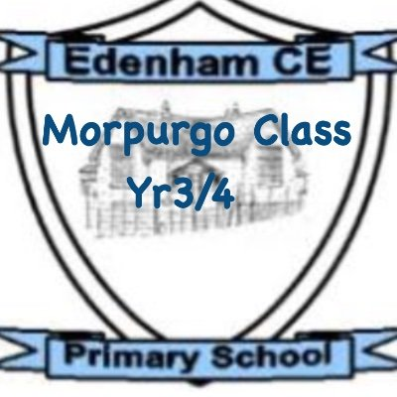
Dear Children, Parents and Carers,
I hope you all had a restful and fun-filled week. We have got another busy term ahead of us, including an Egyptian WOW Day. Keep an eye on your emails as a date will be sent home very soon. Don’t forget to use your communication books if you have any questions.
Miss Jarvis
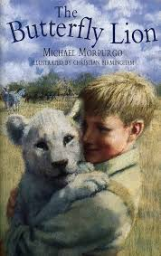
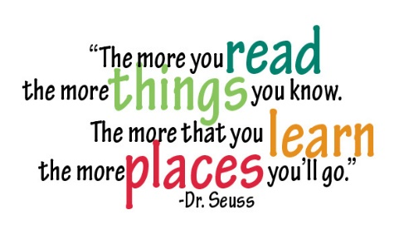
Michael Morpurgo’s book ‘The butterfly Lion’ is going to continue to be our class read again this term. The book will be used during our class-reading sessions, which is made up of pre-reading, reading, post-reading, and an application lesson. The children will be focusing on a different skill each session: Vocabulary, Inference, Predicting, Explaining, Retrieval and Summarising, as well as Decoding and Fluency. During this book focus, the children will have the opportunity to explore the characters of Bertie, Millie, and the lion in more detail by describing their traits, motivations, and changes over time. We will be using hot seating and freeze frames in order to do this.
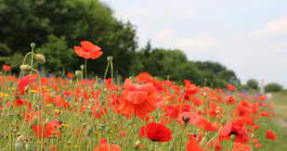
Our first writing piece this term, will be a poem taking inspiration from ‘In Flanders Fields’ by John McCrae. We will be using an image taken from Flanders Fields to gain ideas linked in with our senses. We will be learning to use similes, metaphors and alliteration to make our writing more engaging for the reader. We will then be moving on to writing a set of instructions linked into our work on the Ancient Egyptians.
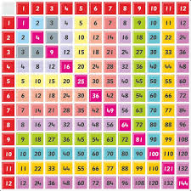
This term in Maths, we will begin with length and perimeter, before moving on to multiplication, division and then finishing off with shape. We will be practicing counting in steps of difference multiplies (e.g. in steps of 4, 6, 7, 8) which will help with our recall of multiplication and division facts for multiplication tables up to 12 X 12. We will also be using formal written methods to solve harder calculations (e.g. a 2-digit number multiplied by a 1-digit number).

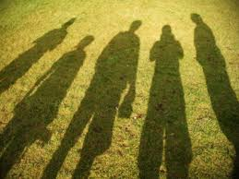
The Science topic this term, is Light. Within this topic, we will be recognising that we need light in order to see things and that dark is the absence of light. We will be noticing that light is reflected from surfaces and recognise that shadows are formed when the light from a light source is blocked by a solid object. We will then be looking at patterns in the way that the size of shadows changes. We will also be finding out more about who James Clerk Maxwell is and what he discovered.
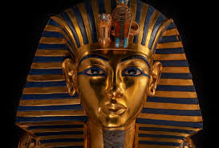
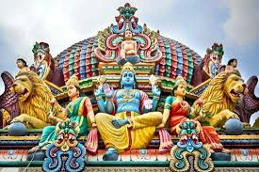
In RE, the second religion the children will be studying is Hinduism. The children will be using Hindu worldviews to answer: ‘What is my duty, how do I know, and why does it matter?’ Using questions and methods drawn from Theology and the Human / Social Sciences, the children will engage with key concepts that underpin a Hindu worldview and will consider the extent to which context affects how Hindus approach fulfilling their Dharma.
In History, we will be learning about the Ancient Egyptians. We will be placing the Ancient Egyptians on a historical timeline and explaining how and why the Ancient Egyptians built the pyramids. We will also be learning about mummification and understanding the significance of Tutankhamun and Cleopatra as pharaohs of Ancient Egypt.
In Art / DT
In French, the second topic will be Les Formes (The Shapes). The children will learn 10 common shapes and also the numbers 1-5. By the end of the unit, the children will be able to recognise, recall, and spell up to 10 shapes with their indefinite articles/determiners.
Our next computing topic will be creating Media using Stop-frame animation. We will be using a range of techniques to create a stop-frame animation using the iPads. Next, we will applying these skills to create a story-based animation, adding other types of media, such as music and text.
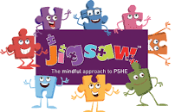
In PSHE, our second unit is based around ‘Celebrating differences’. We will begin by understanding that families are made up in different ways and appreciating the families we have. We will develop our understanding that sometimes differences and conflicts happen among family members. We will then be moving on to knowing what a bully, bystander and witness are and how to report incidents of bullying.
In PE, our second unit of work is based all around ‘Gymnastics’. The children will develop balancing, rolling, jumping and inverted movements and use these skills to create more complex sequences. They will work independently and in collaboration with others to create and develop sequences.
Homework
The most valuable homework you can do with your child is to set aside a short and daily piece of time where you share, read, and enjoy books together.
I will also be sending home some resources to support your child's learning of key numeracy facts, which will help them in Maths this year. These will be sent by Friday 7th November. Also, don’t forget to use Mathletics and Reading Eggs, as you still have access to those. I
PE
PE lessons will be on a Monday, please can you ensure your child comes into school in their PE clothing.
Outdoor Education
The children will have one session of Outdoor Education each week on a Friday. Please can the children come to school dressed appropriately and ensure they bring in a waterproof coat and a pair of named wellies.

