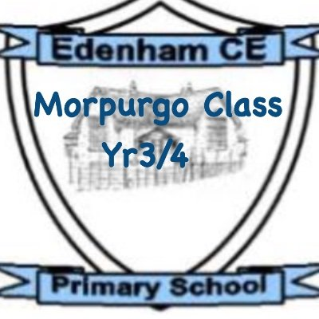
Dear Children, Parents, and Carers,
Welcome back! I hope you all had a restful and enjoyable half-term break. It has been lovely to see the children return with such enthusiasm and energy as we begin the new term. This half term promises to be a busy and exciting one, filled with new learning opportunities, creative projects, and plenty of chances for the children to continue growing in confidence and independence.
Please don’t forget, if you ever have any questions, messages, or queries, please use the communication book or don’t hesitate to catch me at the end of the day.
Thank you,
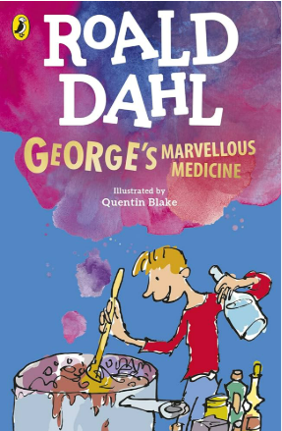
Miss Storer
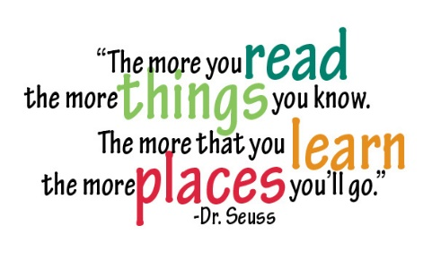
Our class read for this term is George’s Marvellous Medicine by Roald Dahl.

As part of our English learning this term, the children will be exploring the magical world of The Tear Thief by Carol Ann Duffy.
In our writing lessons, the children will begin by writing a recount of their Christmas activities, understanding the importance of chronological order. The children will also be learning about mythical creatures. By the end of the unit, they will design their own magical creature, write a non-chronological report about it, and share their work with Blackman Class, telling them all about the animal they have created.
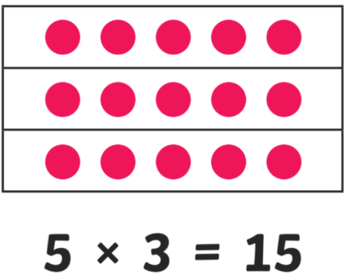
The children will continue to develop their reading and writing with daily phonics lessons in individualised, smaller groups.
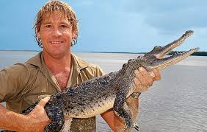
In Maths this half term, the children will be developing their understanding of multiplication, division and fractions. They will be exploring different strategies to solve multiplication and division problems, building confidence with arrays, grouping and sharing. We will also be learning about fractions, including identifying halves and quarters and finding fractions of quantities in practical, hands-on ways. These skills lay important foundations for their future mathematical learning, and the children will have lots of opportunities to apply their knowledge through problem-solving and real-life contexts.
In Science this half term, our topic is Animals Including Humans. The children will be learning about what animals—including humans—need in order to survive, such as food, water, air and shelter. We will also be exploring life cycles, looking closely at how a frog develops from frogspawn to a fully grown adult, and comparing this to the human life cycle. As part of our learning, we will also be finding out about our key scientist, Steve Irwin, whose passion and dedication to understanding and protecting wildlife continues to inspire people around the world. Through hands-on activities, observations and discussions, the children will build a deeper understanding of how living things grow, change and depend on their environment.
In RE this half term, the children will be exploring the key question: “Is it possible to communicate with God?” They will be learning about how different faiths understand and respond to this idea, with a particular focus on the similarities and differences between Jewish people, Christians, Muslims and Sikhs. Through stories, discussions and examples of prayer and worship, the children will consider how people from these religions believe they connect with God, why communication is important in their faith, and how these practices help guide their daily lives.
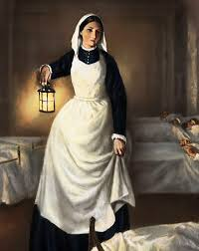
In History this term, the children will be learning about women who changed history. Throughout the unit, they will explore the lives and achievements of five significant women: Rosa Parks, Emmeline Pankhurst, Edith Cavell, Mary Seacole and Florence Nightingale. The children will learn about the remarkable acts of bravery, determination and compassion that made these women influential figures and helped to shape the world we live in today. Through stories, timelines and discussion, the children will reflect on how each woman’s actions made a lasting impact and why they continue to be remembered as important historical figures.
In DT this half term, the children will be designing and making their own weather stations, developing their understanding of measurement, structure and purposeful design.
In Computing this half term, the children will be learning how to collect, record and organise data in different ways. They will also explore how to group data to help them spot patterns and understand information more clearly.
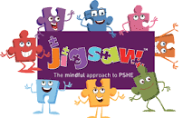
In PSHE, our unit is based around ‘healthy me’. The children will learn about being healthy, making healthy choices, and keeping clean and safe. The unit also explores medicine safety and road safety, helping children understand how to look after themselves in everyday situations. The final lesson, Happy, Healthy Me, brings everything together, encouraging the children to think about how healthy habits support their overall wellbeing.
In Music this half term, the children will be learning about storytelling through music, exploring how composers use tempo and dynamics to create mood and bring a story to life. They will have the chance to experiment with these musical elements themselves as they compose and perform short pieces
Homework
Reading daily is incredibly valuable for your child’s progress—it doesn’t need to be for long, but regular practice makes a big difference. When reading together, asking simple comprehension-style questions and discussing the plot will help engage your child and deepen their understanding of the story.
PE
PE lessons will be on a Thursday, please can you ensure your child comes into school in their PE clothing.
Outdoor Education
The children will have one session of Outdoor Education each week on a Thursday. Please can the children come to school dressed appropriately and ensure they bring in a waterproof coat and a pair of named wellies.

