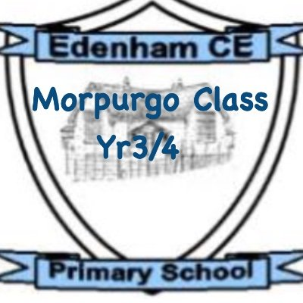
Dear Children, Parents, and Carers,
I hope you have all had a Happy Christmas and I wish you a Happy New Year! I’m really excited to meet you all properly and to work together to help your children learn and grow this term.
Please don’t forget, if you ever have any questions, messages, or queries, please use the communication book or don’t hesitate to catch me at the end of the day. I look forward to hearing all about what the children got up to over the Christmas break.
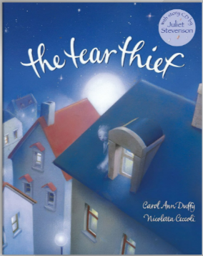
Our class read for this term is The Tear Thief.
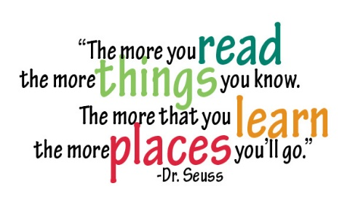

As part of our English learning this term, the children will be exploring the magical world of The Tear Thief by Carol Ann Duffy.
In our writing lessons, the children will begin by writing a recount of their Christmas activities, understanding the importance of chronological order. The children will also be learning about mythical creatures. By the end of the unit, they will design their own magical creature, write a non-chronological report about it, and share their work with Blackman Class, telling them all about the animal they have created.
The children will continue to develop their reading and writing with daily phonics lessons in individualised, smaller groups.
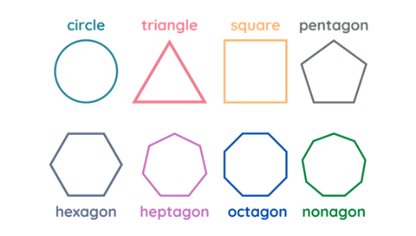
This term in Maths, we will begin with shape. The children will be able to identify and recognise 2D shapes in different contexts, discuss their properties, as well as recognise and create different patterns. Later in the term, the children will continue learning about place value and number, measurement (mass and weight) and build on their understanding of addition and subtraction.
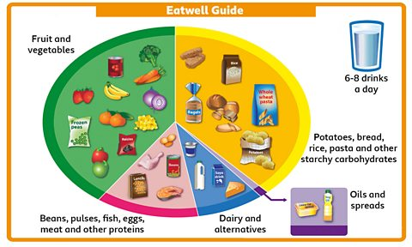
In Science this term, the children will be learning about how to keep healthy. They will find out why eating the right types of food in the right amounts is important and learn about the five food groups on the Eatwell Plate. The children will also explore examples of foods in each group and understand why we need a range of foods to stay healthy. We will talk about the importance of keeping clean and how exercise helps us stay fit and strong. Finally, the children will learn about how people, like Joe Wicks, encourage healthy eating and exercise.
In RE, the children will be learning about the religion, Islam. They will be answering this key question: Who is Allah (God) to Muslims, and why does Allah (God) matter to them?
In Geography, we will be learning about England vs Kenya. The children will be exploring the similarities and differences between life in Kenya and life in England.
In Art, the children will be developing their drawing skills by completing still life drawings and improving their pencil control.
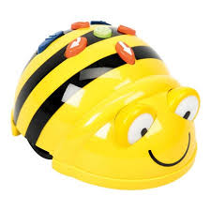
Our next computing topic will be exploring the concept of programming. The children will be learning about moving robots, using Bee Bots. This unit introduces learners to early programming concepts. Learners will explore using individual commands, both with other learners and as part of a computer program. They will identify what each floor robot command does and use that knowledge to start predicting the outcome of programs. The unit is paced to ensure time is spent on all aspects of programming and builds knowledge in a structured manner. Learners are also introduced to the early stages of program design through the introduction of algorithms

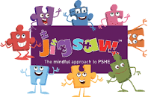
In PSHE, our third unit is based around ‘Dreams and Goals. In this unit, the children will understand what success is, discuss what they wish to achieve whilst understanding that they may need to overcome challenges along the way.

In Music this term, the children will be exploring African call and response songs with an exciting animal theme. They will learn how to create their own musical patterns and understand how changing the dynamics (loud and quiet sounds), tempo (speed), and timbre (the sound quality) can represent different animals. This will help them develop their listening skills, creativity, and confidence in performing.
Homework
The most valuable homework you can do with your child is to set aside a short and daily piece of time where you share, read and enjoy books together.
PE
In PE, our third unit of work is based all around ‘Gymnastics’.
PE lessons will be on a Thursday, please can you ensure your child comes into school in their PE clothing.
Outdoor Education
The children will have one session of Outdoor Education each week on a Thursday. Please can the children come to school dressed appropriately and ensure they bring in a waterproof coat and a pair of named wellies.

