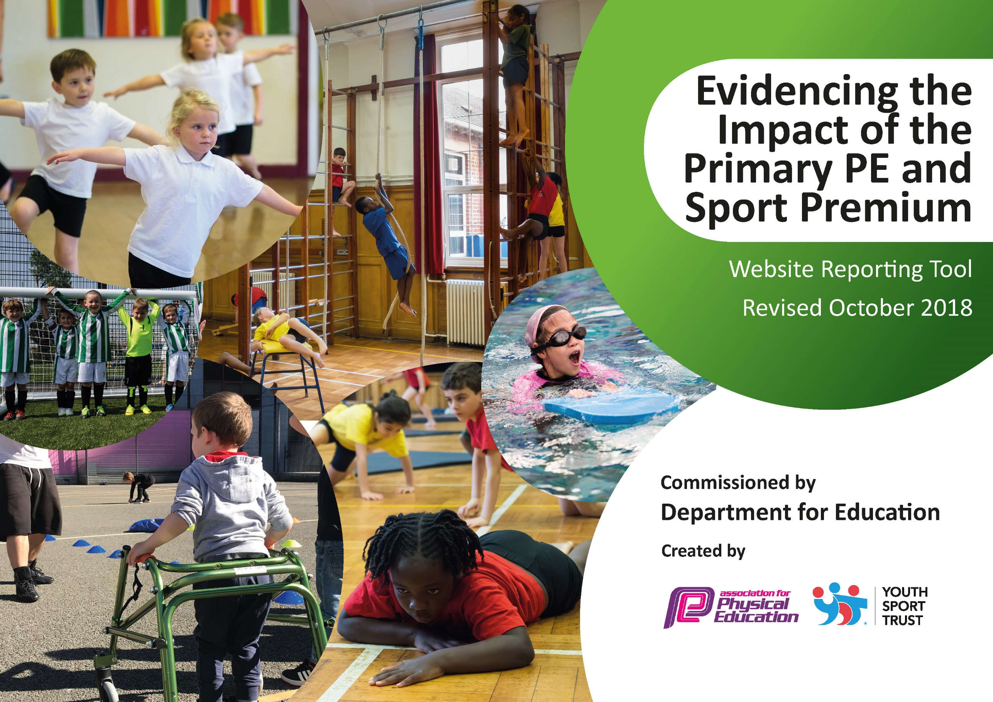
Evidencing the impact of P.E and Sports Premium at Edenham CofE Primary School


September 2025
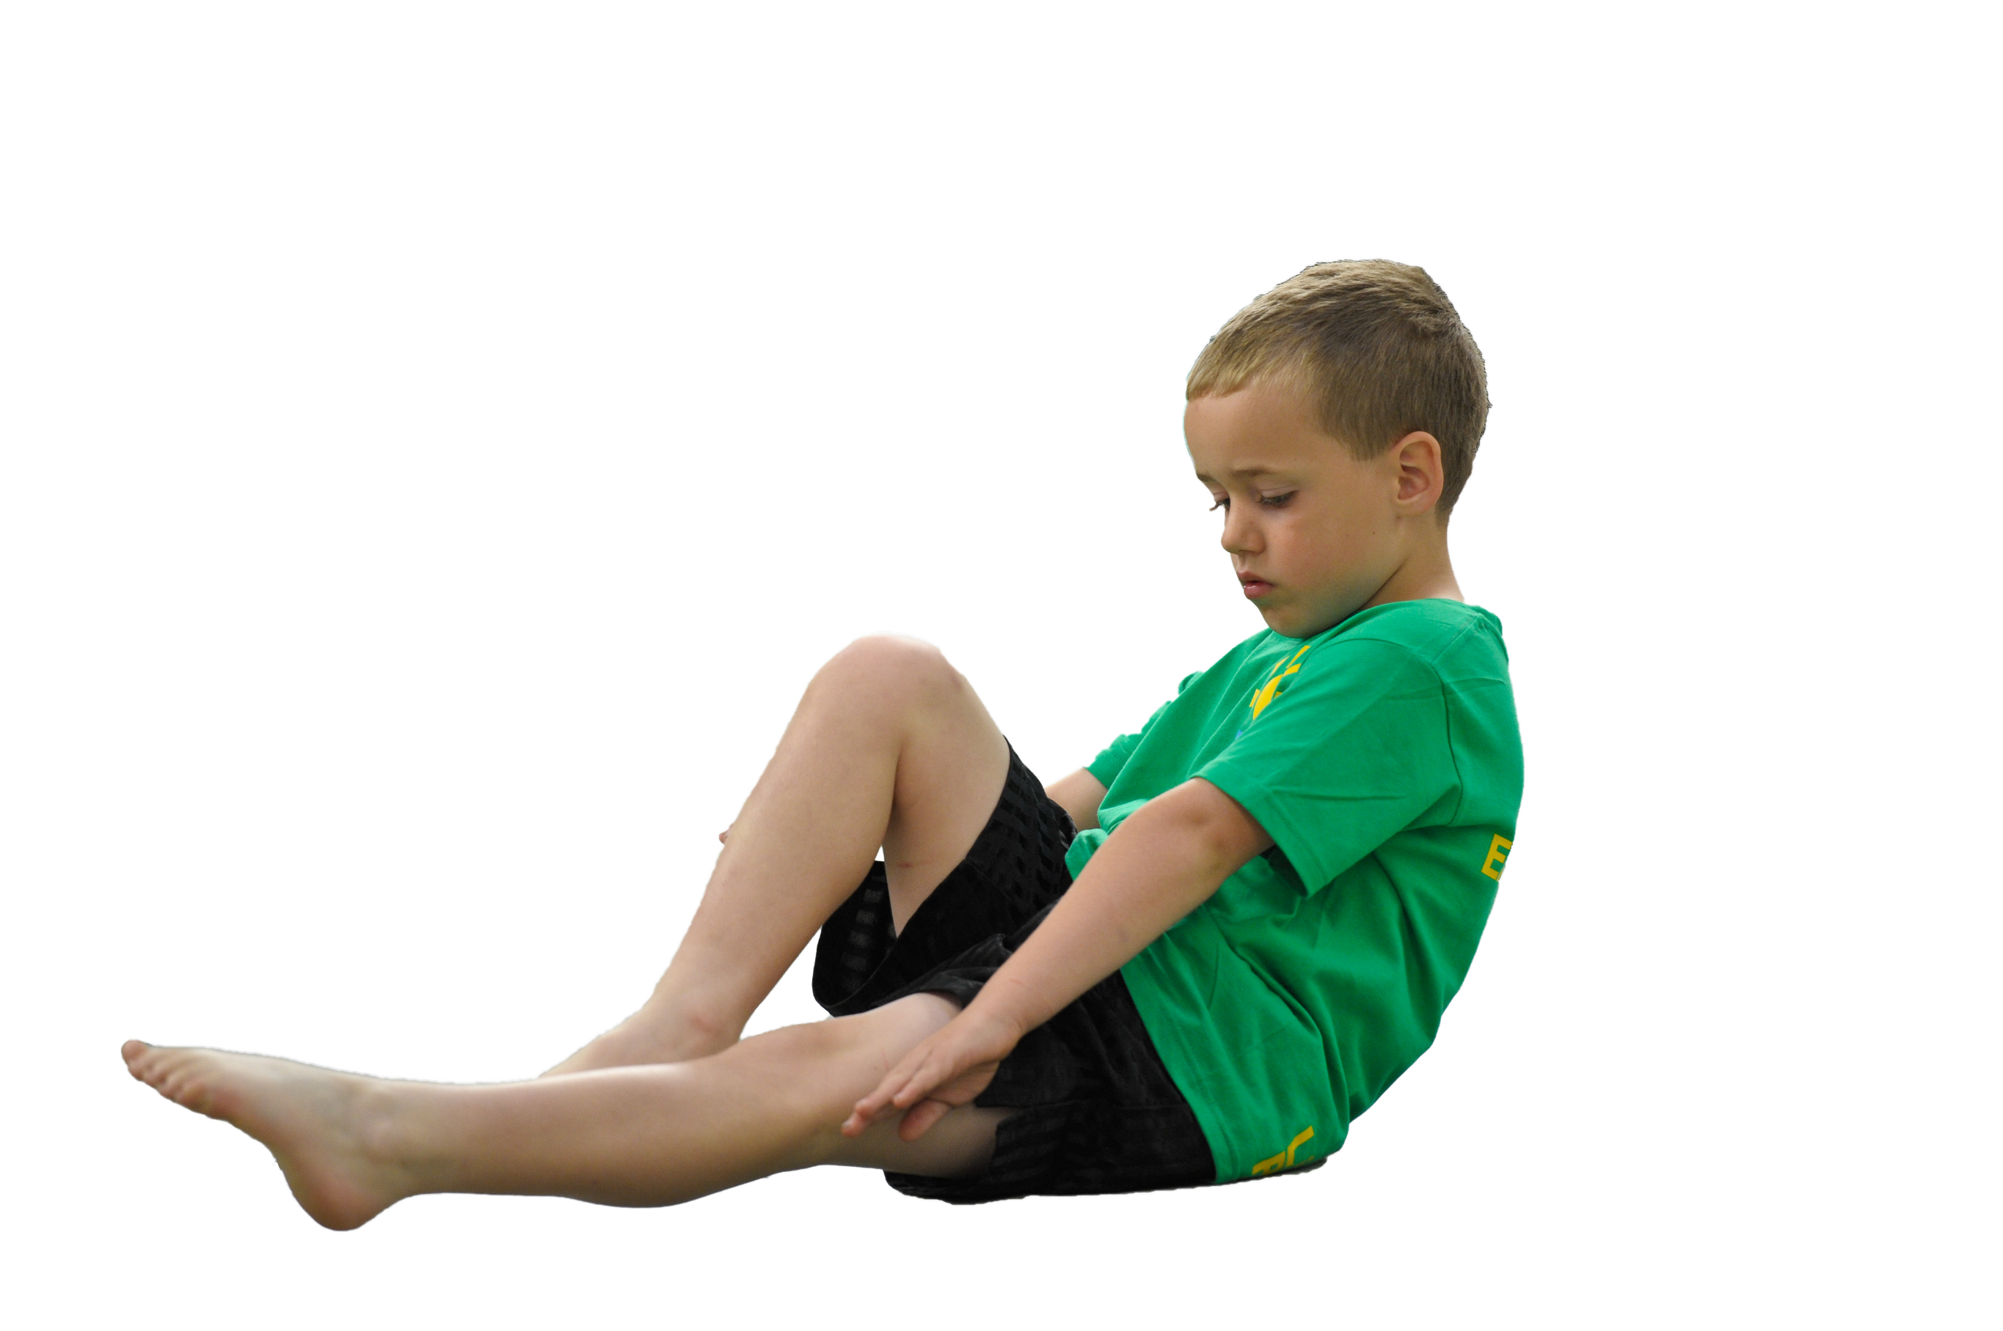
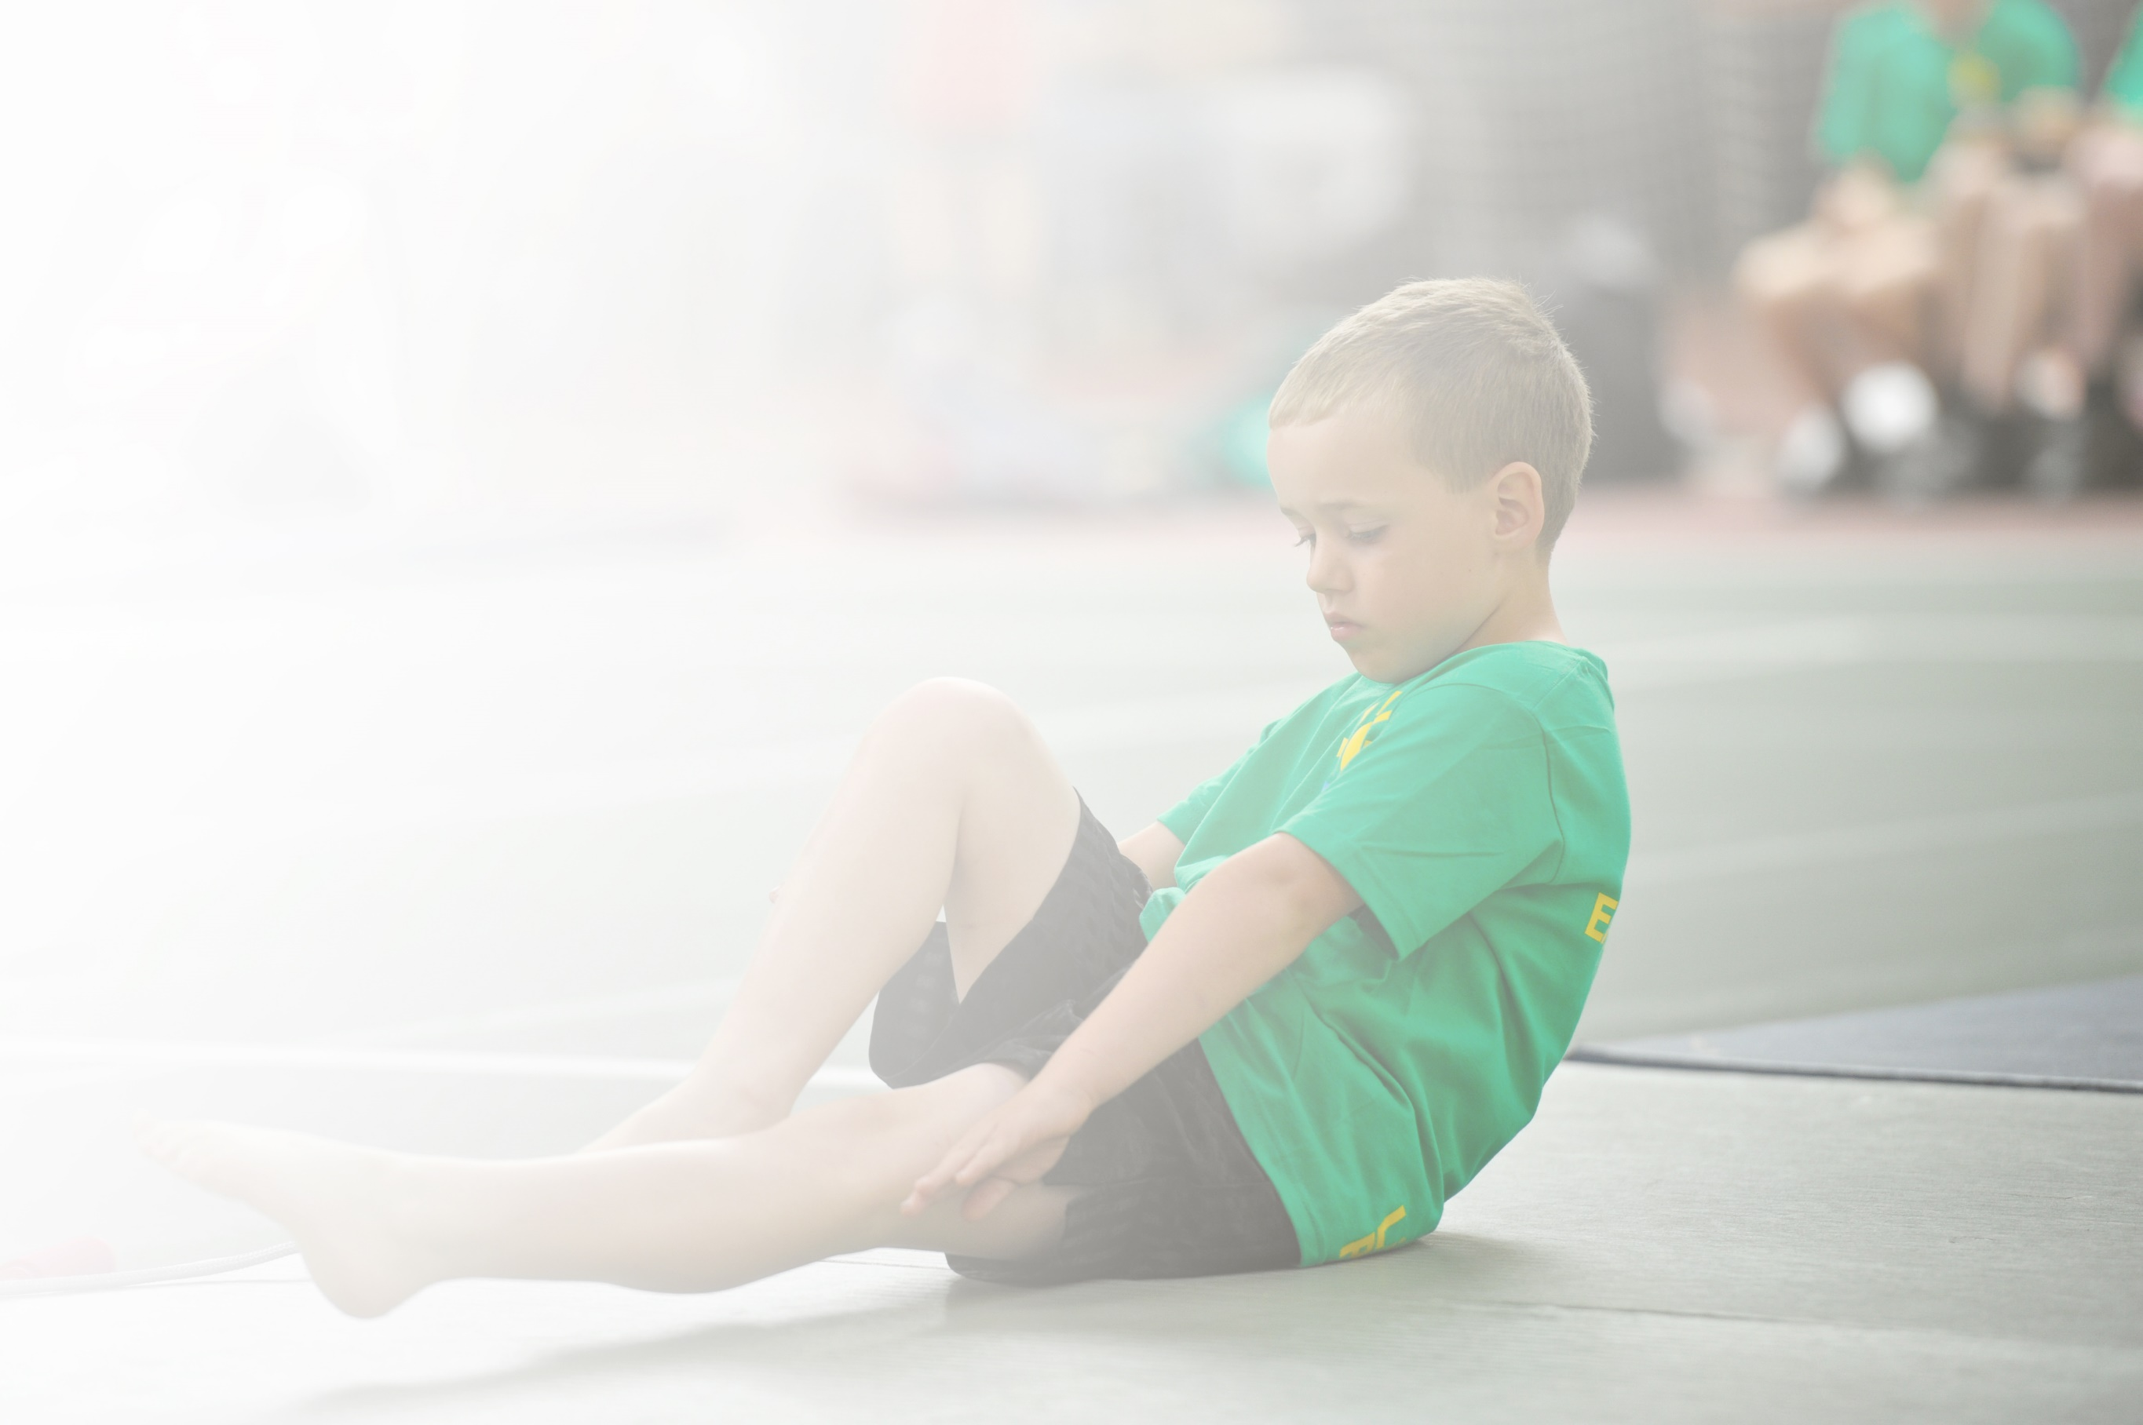
Schools must use the funding to make additional and sustainable improvements to the quality of Physical Education, Sport and Physical Activity (PESPA) they offer. This means that you should use the Primary PE and Sport Premium to:

- Develop or add to the PESPA activities that your school already offer
- Build capacity and capability within the school to ensure that improvements made now will benefit pupils joining the school in future years

Please visit gov.uk for the revised DfE guidance including the 5 key indicators across which schools should demonstrate an improvement. This document will help you to review your provision and to report
your spend. DfE encourages schools to use this template as an effective way of meeting the reporting requirements of the Primary PE and Sport Premium.

We recommend you start by reflecting on the impact of current provision and reviewing the previous
spend. Under the Ofsted Schools Inspection Framework, inspectors will assess how effectively leaders use the Primary PE and Sport Premium and measure its impact on outcomes for pupils, and how effectively governors hold them to account for this.

Schools are required to publish details of how they spend this funding as well as on the impact it has on pupils’ PE and sport participation and attainment by the end of the summer term or by 31 July 2019 at the
latest.
We recommend regularly updating the table and publishing it
on your website throughout the year, as evidence of your
ongoing review into how you are using the money to
secure maximum, sustainable impact. To see an
example of how to complete the table please
click HERE.

Support for review and reflection - considering the 5 key indicators from DfE, what development needs are a priority for your setting and your students now and why? Use the space below to reflect on previous spend, identify current need and priorities for the future.

Key achievements last year: | Areas for further improvement and baseline evidence of need:
Pupils all receive weekly Outdoor Education which has raised activity and OAA participation  The variety of activities and skills children are taught has increased  Activity throughout lunch and break times has increased | All children to participate in competitive sports  All children to show progress in the range of skills taught  Staff to become confident in supporting and challenging all learners in all units of P.E taught

Meeting national curriculum requirements for swimming and water safety | Please complete all of the below:
What percentage of your current Year 6 cohort swim competently, confidently and proficiently over a distance of at least 25 metres?  N.B. Even though your children may swim in another year please report on their attainment on leaving  primary school. | 97%
What percentage of your current Year 6 cohort use a range of strokes effectively [for example, front crawl, backstroke and breaststroke]? | 92%
What percentage of your current Year 6 cohort perform safe self-rescue in different water-based situations? | 94%
Schools can choose to use the Primary PE and Sport Premium to provide additional provision for swimming but this must be for activity over and above the national curriculum requirements. Have you used it in this way? | Yes

Action Plan and Budget Tracking
Capture your intended annual spend against the 5 key indicators. Clarify the success criteria and evidence of impact that you intend to measure to evaluate for students today and for the future.

Academic Year: 2024/2025 | Total fund allocated: £16,910 | Date Updated:
Key indicator 1: The engagement of all pupils in regular physical activity – Chief Medical Officer guidelines recommend that primary school children undertake at least 30 minutes of physical activity a day in school |  |  |  | Amount allocated:
 |  |  |  | £3,817
School focus with clarity on intended impact on pupils: | Actions to achieve: | Funding allocated: | Desired impact (end of year review) | Sustainability and suggested next steps:
For enjoyment and participation of activity at break and lunch times to remain high | Physical resources to be audited and replaced if necessary | Resources - £530 PE equip | - Children enjoyment of physical activity has been embedded  - Physical activity every day for each child is common place | For this to continue, updating physical resources and upskilling staff around activities and games that can be played
For children and staff to be upskilled in leading play at lunch and break times | Coach to work with children and model good practice to staff | £2200 Elite  £1087 MSA | - Midday staff to become more confident in leading play  - Ambassadors to be able to lead play  - Children have the opportunity to partake in organised play at break and lunch times | For children to take play ambassador roles
Key indicator 2: The profile of PESSPA being raised across the school as a tool for whole school improvement |  |  |  | Amount allocated:
 |  |  |  | £2,570
School focus with clarity on intended impact on pupils: | Actions to achieve: | Funding allocated: | Desired impact (end of year review) | Sustainability and suggested next steps:
To continue to inspire children to participate in a range of sports in and out of school. | Staff to continue to liaise with local professional and part time clubs building links and hosting visits  Continue to make links with local grassroots clubs  Continue to make it possible for children to access local sporting events | Transport - £500 | - The number of children partaking in extra-curricular activities continues to grow  - Children are aware of what it means to be part of a team | For this to continue with Elite Sports provided activities and clubs
For their to continue to be a wide offer of clubs available to children | Survey to be carried out finding out what clubs children would like  Staff to be supported in running clubs  Coach and P.E lead to lead clubs and model good practice | Staffing - £1045 | - The number of children attending a club remains high  - Physical activity is continues to be high throughout the week  - Children enjoyment of physical activity continues to rise | For termly surveys to be carried around clubs
For P.E lead to lead effectively throughout school ensuring effective deliver of the P.E curriculum | Staff to observe coaches leading P.E | Staffing - £525  Physical resources - £500 | - P.E is lead effectively  - Children receive effective teaching of P.E  - Children making progress in all areas of the P.E curriculum | For monitoring of P.E to become more strategic

Key indicator 3: Increased confidence, knowledge and skills of all staff in teaching PE and sport |  |  |  | Amount allocated:
 |  |  |  | £2,735
School focus with clarity on intended  impact on pupils: | Actions to achieve: | Funding  allocated: | Evidence and impact: | Sustainability and suggested  next steps:
For staff to improve effectiveness of P.E teaching | - For staff to feel confident leading active sessions  - Coach to model good practice and liaise regularly with staff  - Coach to support teachers in revising plans to ensure support and challenge | Coach - £2235 Elite  Scheme of work - £500 | - A broad and progressive P.E curriculum is taught.  - Staff adapt practice based on assessment of children  - Children’s skills and knowledge improve
Key indicator 4: Broader experience of a range of sports and activities offered to all pupils |  |  |  | Amount allocated:
 |  |  |  | £5,040
School focus with clarity on intended  impact on pupils: | Actions to achieve: | Funding  allocated: | Evidence and impact: | Sustainability and suggested  next steps:
For children to continue to have access to a range of activities  For clubs to continue to be available in a range of activities  For visitors to inform children about a range of activities and sports | For qualified coaches to provide regular workshops  To purchase resources to provide a range of activities for children  To liaise with Elite sport to access a range of resources | Elite sport - £1,170  SNAG - £200 | All children have accessed activities/sports outside of our curriculum  Staff’s awareness of activities and sports that can be played continues to grow | To improve staff’s knowledge and competence in leading activities
For children to access regular OAA | All children in school to receive outdoor education weekly  Staff to feel confident in leading teaching outdoors | Staffing - £3670 | Children have an understanding of OAA  Children have accessed a range of outdoor activities  A clear and impactful programme of outdoor education is in place | To ensure a complete and rigorous OAA and outdoor education curriculum is in place
Key indicator 5: Increased participation in competitive sport |  |  |  | Amount allocated:
 |  |  |  | £2,768
School focus with clarity on intended  impact on pupils: | Actions to achieve: | Funding  allocated: | Evidence and impact: | Sustainability and suggested  next steps:
To continue to raise the % of children participating in competitive sports, both intra and inter school | Half termly inter-house competitions to occur  Every year group to attend an inter schools sports events  Fixtures for children to represent the school to be organised | Travel - £324  Staffing - £1119  Other competition fees and costs - £300 comps - £1025 | A greater % of children will have participated in competitive sport | For inter-house activities to become more strategically planned

